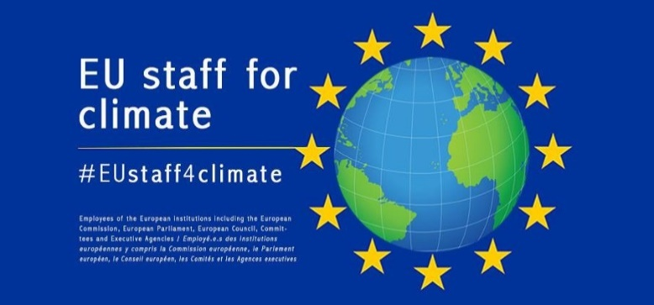

EU Staff for Climate, 1st open meeting
DM 24 (Rue De Mot 24, room 03/47) - 4 April 2019 – 6 -8 pm
Agenda
Objectives:
- Agree on a common vision for EUstaff4climate
- Set up working groups with specific objectives
- Agree next meeting – objectives and date

- Introduction – why are we here ? (10 min)

- Tour de table – expectations (20 min)

- Vision – broad objectives for EU Staff for Climate (20 min)

- Proposed working methods (50 min)

  - What are we already doing ? Short presentations (max 5 min each) on actions on :
Individual footprint – (EMAS Commission, tbc)
Institutional footprint – (EMAS EP, tbc)
Policy ambition – (CLIMA, tbc)
  - What do we want to work on ?

  - Setting up working groups

  - Quick brainstorming on potential next activities (e.g. lunchtime conferences, meetings with experts, participating in marches…)

- Next steps (10 min)

  - Overall coordination (do others want to get involved ?);

  - Next meeting (objectives and timing).

